Computer Language Coding Concepts

Controlling a Related Object in a Diagram
The term related object is basically synonymous for object reference, because a related object does not yet define anything about the relation between a parent and a child. A related object is the undecorated pointer to an object, contained inside a →1 related item or a →n related list item.

There is a slight difference between the term object reference and the term related object.
The term object reference stands for any place an object is referred to. A related object only has one residence: directly inside a → related item or inside a →n related list item.

A related object is a controlled object reference, wrapped inside a → related item or inside a →n related list item.

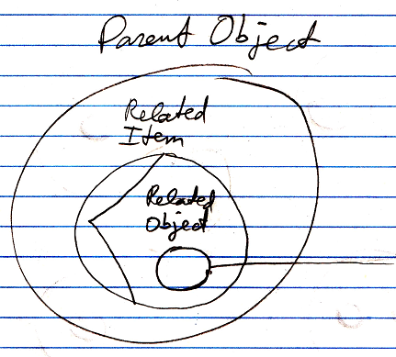

See also: System Objects

Author & Copyright: Jan-Joost van Zon Date: June 18, 2008 – June 18, 2008 Location: Oosterhout, The Netherlands Status: Finished

